**Brooklyn torah gazette**

**For parshas tetzaveh 5782**

Volume 6, Issue 21 (Whole Number 276) 11 Adar I 5782/ February 12, 2022

**Printed L’illuy nishmas Nechama bas R’ Noach, a”h**

For a free subscription, please forward your request to [***keren18@juno.com***](mailto:keren18@juno.com)

**The Altar**

**By**[**Shraga Sherman**](https://www.chabad.org/search/keyword_cdo/kid/8900/jewish/Sherman-Shraga.htm)



**Artwork by the Rivka Korf Studio**

This week's portion, *Tetzaveh*, is a continuation of the theme that began last week discussing the building of the Tabernacle. This was the portable and collapsible sanctuary that the Jewish people traveled with during their 40 years in the desert. Last week, we read of G‑d's command to build the copper altar upon which the animal sacrifices took place. In the end of this week's portion is the command to erect an additional one, the golden altar, upon which will be offered the incense.

These two altars are very different from the rest of the vessels of the [tabernacle](https://www.chabad.org/parshah/article_cdo/aid/2133493/jewish/What-Was-the-Mishkan-Tabernacle.htm). They did not receive any spiritual impurity, known in Hebrew at *tumaah*. All of the other vessels were able to receive this ritualistic impurity; however, the altars could never be made impure.

The Torah is infinite, and has a depth one can never stop analyzing. So, too, this unique law of the altars not receiving impurity can be given a deeper understanding that gives insight into the soul of every Jew.

[G‑d](https://www.chabad.org/library/article_cdo/aid/433240/jewish/God.htm)'s command to build this tabernacle, in addition to its significance as the focal point for communal worship, also directs each and every one of us to establish a "tabernacle" within our hearts. We are all called upon to make ourselves into a sanctuary in which G‑d's light can dwell and be revealed. As in the general tabernacle, where there were multiple vessels utilized ritually to bring about an indwelling of G‑d's presence, so, too, it is with our own personalized tabernacle.

**Vessels and Tools**

A person also has "vessels and tools" with which we serve G‑d. They are our brain, heart, mouth, hands, feet, etc. The Jewish person is called upon to activate his mind in the learning of [Torah](https://www.chabad.org/library/article_cdo/aid/1426382/jewish/Torah.htm); to fill his heart with love and awe of G‑d; to speak with his mouth words of Torah and prayer; to fulfill the mitzvot with his hands; to use his feet to go do a mitzvah, so that all the limbs of our body participate in acts of holiness. In such a way, we actualize the goal of transforming ourselves into a tabernacle for G‑d.

It happens from time to time that our "vessels" become spiritually impure. When we use our mind, emotions and his other soul strengths and capacities for inappropriate things, we thereby make them impure. In order to return and rededicate our tabernacle to G‑d, one needs to go through the process of teshuvah ("repentance"), which purifies anew the vessels we possess.

However, there is one vessel for which it is impossible to descend into a state of impurity — the altar. The altar, the focal point of the Tabernacle, represents complete submission to G‑d and eradication of an egocentric attitude, as all is consumed by the abounding love of G‑d. As the quintessence of the person's being is revealed, impurity becomes an impossibility. The altar symbolizes the essence of the soul in each and every Jew.

This is the *pintele yid*, the core point of Judaism, which never loses its purity. It is not even affected by a person's behavior or stream of thought. This innermost, raw sense of being that remains constantly—and always—connected to G‑d demonstrates how a Jew does not want, nor is truly able, to separate from his or her Judaism.

*Reprinted from the Parshat Tetzaveh 5782 email of Chabad.Org Magazine.*

**Rabbi Berel Wein**

**On Parshas Tetzaveh**

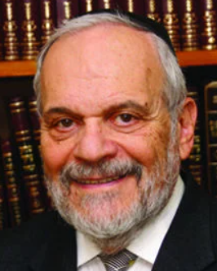

In the Torah reading of this week, a great deal of emphasis is placed on the preparation of the oil that will be the fuel for the flames of the great Candelabra that existed in the Tabernacle and, later, in the Temple in Jerusalem. The Torah emphasizes that the oil to be used must be of the purest kind, refined to produce only illumination. Through this verse, the commentators attempt to explain why such a special emphasis is to be placed on the oil.

Perhaps it would be sufficient for the Torah to simply command that the flames that emanated from the Menorah should be of the highest quality and have the greatest power of illumination. We would then understand that to produce flames of such a nature and quality, only the finest oil possible would have to be produced for the Candelabra to possess that proper fuel and extraordinarily fine flames. Thus, we see that the Torah emphasizes the preparation of the oil in more detail and with greater urgency than it does the description of the flame of the Candelabra that results.

In a strange way, it is as though the oil itself, which after all is only the fuel in the cup of the lamp of the Candelabra, somehow receives more prominence and detailed instruction than the flame itself. Not only that, but the great Candelabra has miraculous powers, and one of its lamps burned continuously, according to many commentaries, without having any added oil to the cup of that lamp. As such, if we are relying on that miracle, then why should the production of the oil for the Candelabra be deemed important at all?

Judaism places great weight not only on the fulfillment and actualization of commandments, but also regarding the preparation that precedes the actual fulfillment of the wishes of Heaven. Holiness and holy acts require preparation and forethought. They are not random acts that rarely occur because of the spontaneity of the moment.

All the holy days of the Jewish calendar require periods of planning – thirty days before the holiday itself, as well as physical, mental, and emotional preparation. One must enter the performance of commandments prepared. They are not to be performed haphazardly and without proper forethought and cognitive intent.

This is also true for the Sabbath day that occurs every week as well as all the daily commandments that we are privileged to perform on a regular basis. The Talmud teaches us that preparation is an important aspect of life – many times as important as actualizing the commandment.

Without proper preparation, performance of the commandments is likened to a body to which no soul is attached. Therefore, if we understand and appreciate this attitude towards life and commandments, we can readily appreciate why the Torah is so emphatic regarding the necessary methods of production of the oil to be used to light the lamps of the holy Tabernacle and Temple.

*Reprinted from this week’s website of rabbiwein.com*

**Thoughts for Our Parsha**

*Pure olive oil, pressed for the light* (Exod. 27:20)

The first drop of oil pressed from an olive is the finest, and that was the oil used to light the menora in the Holy Temple. The remaining oil in the olive was used for meal offerings. This is the reverse of what is normally done.

Usually, one would use the best oil for cooking and the cheaper oil for lighting. The menora is a symbol of spirituality. It represents Torah and mitzvot. Unfortunately, there are some who might plead poverty when they have to spend money for Torah or mitzvot, but spend lavishly on personal pleasures. We learn from this that for Torah and mitzvot one should spend money for the best and the purest, and for personal pleasure a Jew should practice restraint and learn to suffice with less. *(Klei Yakar)*

*Reprinted from the Parshat Tetzaveh 5757/1997 edition of L’Chaim. Adapted from Likutei Sichot Vol 3.*

**Rav Avigdor Miller on**

**Shabbos and Yetzias Mitzrayim**



**QUESTION:** **In kiddush on Friday night we say that Shabbos is**zeicherl’yetzias Mitzrayim;**it’s a remembrance of our going out of Egypt. In what way is Shabbos supposed to remind us of**Yetzias Mitzrayim?

**ANSWER:** Shabbos shows that Hashem chose us to be His people; we were chosen to be the nation that testifies that Hashem created the world out of nothing. “אתם עדי” Hashem said. “You are My witnesses.”

Even though the creation of the world from nothing was for all the nations, we are the ones chosen to be His witnesses to testify to the truth of His existence and to His creation of the world from nothing. That’s our job in this world; to never back down from testifying to Hashem’s creation of this world from nothing. And the most fundamental way we testify to that truth is by keeping Shabbos.

Now, when were we chosen for this job? We were chosen in Mitzrayim. At Yetzias Mitzrayim Hashem chose us. שלח את בני – “Send out My son,” Hashem said. That’s the first time Hashem said that. It was at Yetzias Mitzrayim that Hashem called the Am Yisroel “My son,” because it was then that we were chosen.

And He chose us for what? שלח את בני ויעבדוני – Send out my nation so that they should serve Me. It means that it was at Yetzias Mitzrayim that Hashem chose us to serve Him. It says that openly: “Send My people out.” For what? “So that they should serve Me.”

So, it was at the time of Yetzias Mitzrayim that we were chosen for this job of being His witnesses by celebrating Shabbos and thereby testifying to the briyah yesh mei’ayin. And that’s one of the reasons why we mention Yetzias Mitzrayim in kiddush Friday night – because Yetzias Mitzrayim is when it all began.

*Reprinted from the January 28, 2022 email of Toras Avigdor. Adapted from Tape #E-229.*

**The First Rabbi in America: Rabbi Abraham Rice Part 2**

**By Dr. Yitzchok Levine**

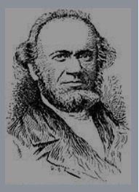

However, Rabbi Rice did not take into account how many of his congregants did not keep Shabbos. The minutes of some of the shul meetings relate that even some of the officers of the synagogue were charged with doing business on Shabbos.

In addition, aliyos meant donations, and these played a crucial role in the finances of the synagogue. Rabbi Rice was forced to rescind his original directive.

Instead, he allowed non-Sabbath observers to be called to the Torah but forbade the answering of “amen” to their brachos. One can well imagine how this was “accepted.” Some wanted other changes, and Rav Rice often found himself and his commitment to Orthodoxy under attack.

An uneasy peace prevailed in the congregation. Two years after Rabbi Rice’s arrival in the city, however, a minor revolt of great historic significance broke out.

To a funeral service for a member of the congregation, one Jacob Ahrens, at which the rabbi officiated, came friends of the deceased who were members of Masonic and Odd Fellows lodges to which Ahrens belonged.

These gentlemen performed at the grave certain rites customary in their societies. The rabbi remonstrated there and then. In protest against Rabbi Rice’s action, some members left the congregation and formed the Har Sinai Verein, which was destined to become the first lasting Reform congregation organized in Baltimore and, indeed, in the United States."

**A Despairing Letter to His Teacher**

Things deteriorated to the point where Rabbi Rice wrote the following despairing letter to his former teacher, Rav Wolf Hamburger: “I dwell in complete isolation (obscurity) without a teacher or a companion in this land whose atmosphere is not conducive to wisdom; all religious questions (shaalos) are brought to me for solution.

“I have to carry the full load on my shoulders and have to assume the authority to render decisions in halachic questions in both private and public matters.

**My Soul Weepeth in the Dark…**

“And one more thing I wish to disclose to you my revered master and teacher…and my soul weepeth in the dark on account of it, namely, that the character of religious life in this land is on the lowest level; most of the people are eating non-kosher food, are violating the Shabbos in public…and there are thousands who have been assimilated among the non-Jewish population and have married non-Jewish women.

“Under these circumstances, my mind is perplexed, and I wonder whether a Jew may live in a land such as this. Nevertheless, in my own home – thank G-d – I conduct myself as I did in days of old in my native country. I study Torah - day and night, and my devoted and G-d fearing wife is always standing by and helping me with all her strength, in spite of privation and difficulties.

**“Life Has Lost All Meaning”**

“Yet in spite of all this, life has lost all meaning here on account of the irreverence and low estate of our people. Alas, therefore, my master and teacher, impart to me of your wisdom, and let me have your august opinion in the matter; for often times I have made up my mind to leave and go from here to Paris and to put my trust in the good Lord."

Despite all of this Rabbi Rice was able to make some sort of peace with his situation and accomplish much for Orthodoxy. To be continued iys next week.

Reprinted from the Parshas Tetzaveh 5782 email of whY I Matter, Yedidye Hirtenfeld’s parsha sheet for the Young Israel of Midwood in Brooklyn.

**The Significance of the Temple Altar**

**And the Essential Spark of Every Jew**

**From the Talks of the Lubavitcher Rebbe**

**Rabbi Menachem Mendel Schneerson, Zt”l**

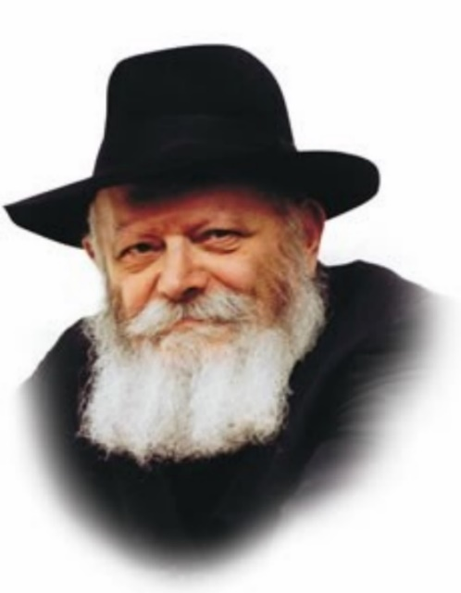

In this week's Torah portion, Tetzaveh, the Torah speaks of the Sanctuary's golden altar. Last week's portion dealt with the altar of copper.

The Mishna explains that the altars cannot become ritually impure. According to one opinion, this is because the altars are like earth, which can never acquire ritual impurity. A second opinion holds that the altars cannot be defiled as they are only a covering for the earth they contain; the altars are of secondary importance to their essence, which is always pure.

In the allegorical sense, every Jew is a "Sanctuary" in which the Divine Presence dwells. And just as the physical Sanctuary was made up of various components and vessels, so too is the spiritual Sanctuary comprised of the Jew's "vessels": intellect, emotions and feelings, etc.

A Jew will sometimes have inappropriate thoughts, i.e., thoughts which are contrary to the will of G-d, in conflict with the Torah and its commandments. When that occurs, the "vessels" of the Jew's Sanctuary are defiled, and he must look for a way to purify them. The impure thought must be removed and "cleansed," and the "vessel" restored to its former status.

People fall into two main categories of economic standing: rich and poor. Rich people are likened to the Sanctuary's golden altar; poor people, to the copper altar. However, both rich and poor possess the same essential point, the Jewish spark that is always whole and wants to carry out G-d's will.

In the spiritual Sanctuary, the Jewish spark is equivalent to the altar. It is the truest and most essential part of the Jew's makeup, the part that can never become impure.

Thus, both "golden altars" and "copper altars," Jews who are rich and poor in the spiritual sense, are equal when they remember that they are "altars" -- when their Jewish spark is aroused and their desire to fulfill G-d's will is revealed.

The altar, the inner essence of the Jew, is always pure, like the earth that is trodden upon by all. When a Jew's entire being is nullified before G-d and his only aspiration is to do what G-d requires of him, he can never become impure. According to the second opinion of the Mishna, the altars do not acquire impurity because they are only a covering, of gold or of copper.

A wealthy Jew may be so involved with his business that he fails to fulfill G-d's will. A poor Jew, because of his poverty, may also sometimes transgress. Yet in all Jews the essential spark is always pure. For wealth or poverty is only a covering superimposed over the Jew's essential nature. While the outer covering may become sullied, the inner essence remains untouched; for the Jew's true desire is to fulfill the will of G-d.

*Reprinted from the Parshat Tetzaveh 5757/1997 edition of L’Chaim. Adapted from Likutei Sichot Vol 3.*

**More Thoughts for Our Parsha**

*And you shall command the Children of Israel* (Exod. 27:20):

The name of Moshe is not mentioned in this Torah portion because Moshe died on the seventh day of the month of Adar, which usually falls during the week that this Torah portion is read. *(Me'or Einayim)*

*Now you shall command* (Exod. 27:20):

The word used for command, "tetzaveh," is related to the word "tzava'ah," which means "will." Just like a parent leaves a will and testament for his children, so too G-d is telling Moshe that there will be a time when he will not be with the Jewish people, and he should leave the following instructions for future generations.

*(Mishkinotecha Yisrael)*

*Reprinted from the Parshat Tetzaveh 5757/1997 edition of L’Chaim.*

**Inside the Mind of the Gabbai**

**By David Olivestone**

[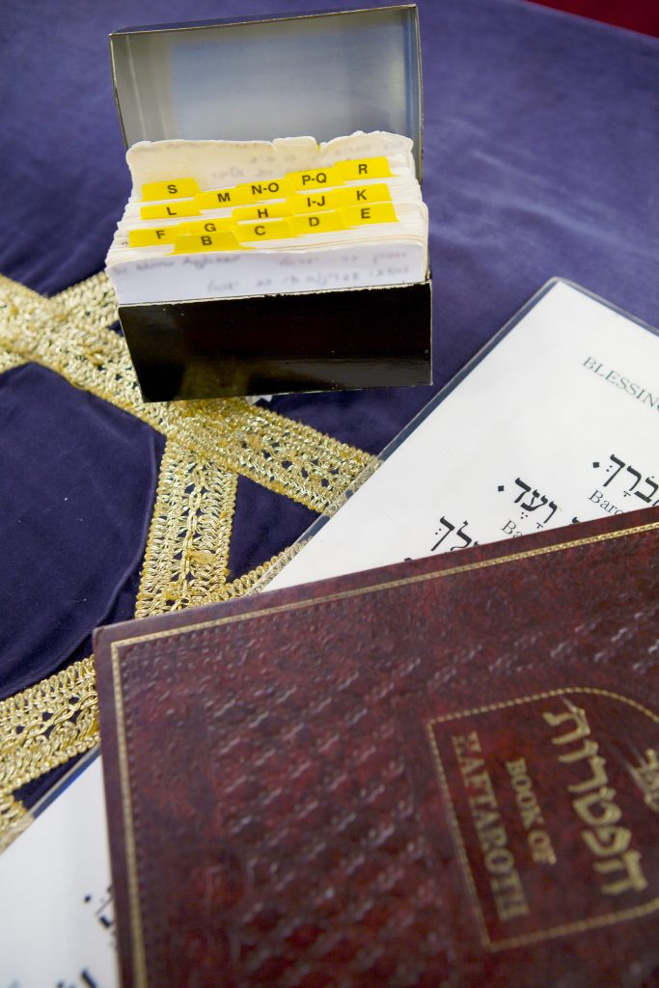](https://jewishaction.com/content/uploads/2021/11/IMG_7711-scaled.jpg)

***Many gabba’im use a card index file to keep records of members’ Hebrew names and the dates on which they received an aliyah. Photo: Erica Berger***

Master of ceremonies, diplomat, event coordinator, social worker, greeter, mediator, mentor—these are just some of the hats that a shul *gabbai* wears.

He has to be both a strategist and a tactician, sometimes patient and sometimes resolute, in some circumstances a heavyweight, in others a charmer. He has to be familiar with the intricacies of the *halachot* of *tefillah*, of *kri’at haTorah*, and of the Jewish calendar, and he has to be a master of interpersonal skills.

The *gabbai’*s responsibilities are multitudinous. On his arrival in the synagogue, he checks the *aron kodesh* and the *sefer*or*sifrei Torah* to be used that day. He selects the *ba’alei tefillah* to lead the various parts of the service.

**Allocating the Many Honors**

He allocates the many honors related to the Torah reading: who will open and close the *aron kodesh*, who will be called for *aliyot*, as well as for *hagbahah* and *gelilah*, and who will read the *haftarah*. He stands at the *bimah*, calls their names, and says the *Mi Sheberach* for them following the reading.

If there is a *simchah* to be celebrated, he must say one of several special *Mi Sheberach* prayers as befits the occasion. If a baby girl was born in the community, it is the *gabbai* who announces what her name will be when the father gets an *aliyah*.

**Reciting the Prayer for the Sick**

He recites the prayer for those who are sick and, at the appropriate times, the Kel Maleh Rachamim when a congregant is observing a*yahrtzeit*. And when newly bereaved *aveilim* come to shul to say Kaddish, it is often the *gabbai* who gently and sensitively shepherds and guides them.

**Watching Out for**

**Distinguished Guests**

As the service progresses, he must keep a watch for any distinguished guests, so as to properly honor them. He must be aware of any members who have a *chiyuv*, such as a *yahrtzeit* that day or in the coming week, or who are celebrating a milestone in their family, and must check to see that they are actually present. If there is any clash of equally eligible *chiyuvim*, he must negotiate a solution that is acceptable  
to all parties.

Meanwhile, the *gabbai* must be on the alert for all the intricate nuances of the service that are triggered by the calendar, such as which *haftarah* to say and whether or not to say Av HaRachamim or, at weekday services, whether or not to say Tachanun.

**Reminding the Cogregation**

**About Ya’aleh Veyavo**

If there is a variation in the usual order of the service, e.g., the addition of Ya’aleh Veyavo on *rosh chodesh,* the *gabbai* reminds the congregation about it either with a *klap* (banging on the desk—see the sidebar on page 28), or by calling it out or both. He is also the keeper of his shul’s specific *nusach* and *minhagim*, and he must make sure that they are faithfully adhered to.

And while he is involved with all of this, he must keep an eye on the level of decorum, as well as on the clock, monitoring how the service is progressing, not too fast, not too slow.

Why would anyone want to take on a role with such an overload of responsibility, with a need for expertise in such seemingly picayune details, with such potential for error or offense, and with such susceptibility to criticism?

**An Informal Survey of Gabba’im**

Yet when asked in a recent informal survey1 of *gabba’im*, “How much do you enjoy being a *gabbai*?,” the overwhelming majority gave answers such as “very much” or “immensely.” Yehudah Powers, former *gabbai* of a minyan in Manhattan, says he “loved it, absolutely loved it.”

Ari Ganchrow, of Teaneck, New Jersey, agrees. “Most of the time it is a big thrill,” he says. And when asked for how long they would want to stay in their positions, nearly half responded “forever!”

**Learning on the Job**

Most *gabba’im* say they learned on the job, although some had their fathers or other *gabba’im* as role models. In some shuls the term of a *gabbai* is limited and is subject to election by the membership, but in many he can continue for as long as he wants, or perhaps until an objection is raised.

There are some, however, who feel trapped in their positions. “No one seems interested in stepping up as my replacement,” writes Effie Love of Queens, New York. Responding from the UK, another *gabbai* echoes his frustration. “There is no queue of willing replacements,”  
he says.

**Filling the role of a shul *gabbai* demands a lot of patience, a thick skin, an organized mind, and an altruistic nature.**

Recruiting volunteers to take on roles in the synagogue seems to be a universal problem. Aaron Alweis, a *gabbai* in Binghamton, New York, points to a major frustration shared by many others—getting people to agree to lead the service.

“People whom I know are capable of *davening* for the congregation consistently refuse to do so,” he reports. “There are a few who will go up if asked, no matter what,” observes another longtime *gabbai,* “but as for the rest—it can be like pulling teeth. Trying to create a variety of *ba’alei tefillah* is very challenging.”

**Recruiting Ba’al Tefillahs**

So, what do *gabba’im* look for in a *ba’al tefillah*on a Shabbat or *yom tov*? Asked to rank the necessary qualities, they put familiarity with the correct *nusach* of the day at the top of the list, followed in order by accuracy of reading Hebrew, a pleasant voice, *kavanah*, reasonable speed, using well-known melodies, popularity, and then level of personal religious observance (perhaps surprisingly) most often in final place.

For a *ba’al keri’ah*, it is no surprise that accuracy tops the list of desirable qualities, followed by a pleasant voice and a good pace, with level of observance again coming in last.

**Monitoring the Accuracy**

**of the Torah Reading**

Monitoring the accuracy of the Torah reading is almost a competitive sport in some synagogues, with many zealots poised to call out a correction at the slightest hint of error.

In fact, when asked whose job it really is to correct the *ba’al keri’ah*, one *gabbai*answered “everyone’s,” while another said it was “whoever shouts loudest.”

But although in some shuls the rabbi alone takes on that responsibility, more often than not it is one of the *gabba’im* who must pay the closest attention to the reading.

Many larger congregations have a “ritual” or “religious” committee which sets the overall policy regarding the shul’s *minhagim*.

**Learning the Quirks of the Members**

But the majority of *gabba’im* report that they have complete freedom in making decisions about whom to honor, with just some occasional input from the rabbi or the synagogue president. “Over time, a good *gabbai* learns the quirks and needs of the members,” says David Zeffren of Los Angeles, California.

But sometimes things can go awry, despite the *gabbai*’s best efforts. It happens, for example, when a member who is due for an *aliyah*shows up late. “Rearranging the *aliyot* on the fly can be very tough,” notes Steve Shach, who has acted as *gabbai*in congregations in South Africa, Nashville, Tennessee, and currently in Sydney, Australia.

Another difficult situation can arise when a congregant who has a *yahrtzeit*or is celebrating a significant family milestone just assumes that the *gabbai* knows about it. Even though that is usually the case, there can always be instances of miscommunication, and if the congregant does not get what he regards as his due, the *gabbai* will hear about it, sometimes loudly.

[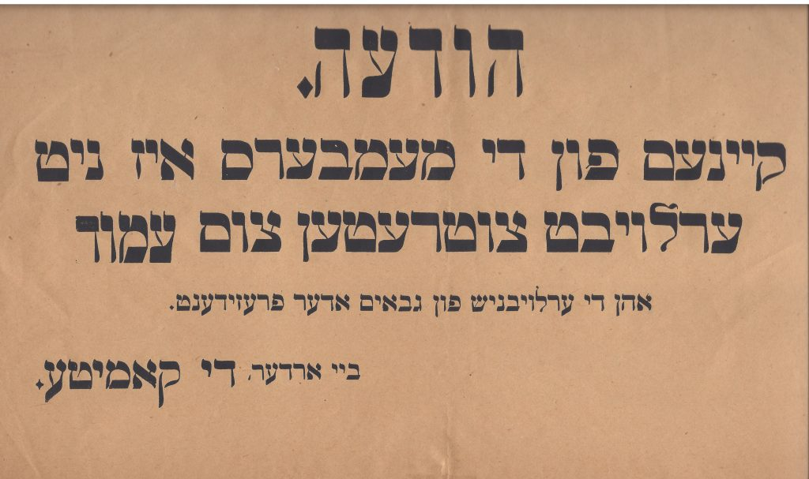](https://jewishaction.com/content/uploads/2021/11/East-End-Shul-Sign-scaled.jpg)

***Early twentieth-century Yiddish sign from a synagogue in London’s East End. It reads: “Notice! None of the members is permitted to take the amud [i.e., lead the davening] without the permission of the gabba’im or the president. By Order, The Committee.” Courtesy of Alan Weisrose***

In terms of allocating *kibbudim*, veteran *gabbai* Dr. Gerald Mayerhoff of Hollywood, Florida, and many others feel that “the most challenging time of year is the period of the Yamim Noraim,” when shuls are at their fullest. But as an example of an even more pressured scenario, numerous *gabba’im* cite those *Shabbatot*when there might be a bar mitzvah, an *aufruf* and a baby naming all on the same day, calling for all their strategizing, negotiating and persuasive skills. But there may simply not be enough *kibbudim* to go around. “Making hard decisions can sometimes even cost you a friendship,” laments Ari Ganchrow.

Yet there’s also another side to the coin. “I enjoyed working with families celebrating *semachot*,” says Dr. Chaim Himmelfarb, who served as a *gabbai* for over a dozen years in various congregations. “It’s a tense time for these families, but working together with them to organize the *kibbudim* was usually much appreciated.” Adds Chaim Kiss of Teaneck, New Jersey, “The most satisfying part is when they say thank you.”

When asked whether they think that their community appreciates how much effort and judgement goes into what they do, many *gabba’im* feel that they are usually taken for granted. But speaking of his experiences in shuls in Boston, Massachusetts and Passaic, New Jersey, Rabbi Adam Dubin feels that “the regulars certainly do appreciate it, and they acknowledge it.” Putting it in perspective, Bart Nierenberg of Longmeadow, Massachusetts, a *gabbai*for over twenty years, feels that “most people are not very aware of the amount of behind-the-scenes work and stage management that is required to do a good job and to keep services running smoothly. We’re at our best when you barely notice that we’re there.”

When they are criticized, most *gabba’im* say they can handle it well if they agree they did indeed make a mistake, but if they feel it is unwarranted, many will take it to heart and, after the service is over, even take it home with them.

How do they balance the demands of their roles in shul with the needs of their families? On the whole, it seems that most of their spouses and children share a sense of pride, as long as it does not take them away from home for too much time. Those with young children, however, feel a pull. “It doesn’t allow me to sit with them in shul as much as I would want,” says Alan Weichselbaum of Lawrence, New York. Also from Lawrence, Mordechai Schrek feels similarly, but adds, “It’s important to imbue in children the importance of being involved in communal endeavors, especially in a shul.”

It is indeed a great sense of commitment to the community that motivates *gabba’im*. Many emphasize the need to “maintain high standards for *ba’alei tefillah* and *kri’at haTorah*.” Robert Rubin of Livingston, New Jersey, derives great satisfaction in “knowing that I made a difference in people’s lives by helping to give them a positive shul experience.” And one after another, *gabba’im* say that what is important to them is to make everyone feel welcome and included, to have the service run smoothly, and “to get it right.”

Still, however much he may be focused on the needs of those around him, the *gabbai* also has his own obligation to *daven* and to fulfill the *mitzvot* of the day. Is it possible for him to *daven*with at least a modicum of concentration while his mind is chock-full of all the myriad tasks he needs to handle? With admirable frankness, most *gabba’im* admit that, unless they attend an earlier minyan first, or *daven*ahead at home, it is indeed extremely hard. But with equally admirable boldness, they are nearly unanimous in stating that the sacrifice is absolutely worth it. David Zeffren’s attitude is typical: “While my personal *tefillot* may suffer, there is great reward in serving the *tzibbur*.”

Filling the role of a shul *gabbai* demands a lot of patience, a thick skin, an organized mind, and an altruistic nature. Motivated by a sincere desire to make the shul service pleasing and acceptable to Hakadosh Baruch Hu and to all who attend, the *gabbai*is the linchpin around whom the whole shul revolves. So what goes through a *gabbai’*s mind as he enters the synagogue? More than anything else, how privileged he is to be the one who orchestrates and conducts it all.

**Note**

1. The questionnaire was circulated informally, through social media and word of mouth. Responses came from *gabba’im* in large and small communities across the US, in Israel, in the United Kingdom and elsewhere. I want to thank all those *gabba’im* who took the time to complete the questionnaire and who were willing to share their experiences, feelings and opinions with me. My thanks also to those who helped me select the topics to be dealt with.

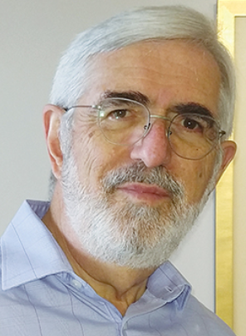

*David Olivestone, a member of the*Jewish Action*Editorial Committee, lives in Jerusalem. Among his previous contributions to the magazine are articles on what goes on inside the minds of the*ba’al teki’ah*, the*chazan*, and the*kohen*.*

*Reprinted from the Winter 2021 edition of Jewish Action magazine, a publication of the OU (Orthodox Union).*

## Thoughts that Count for Our Parsha

*They should take for you pure olive oil, pressed for the light, to kindle the lamp continually* (Exod 27:20)

It seems unnecessary to add "to kindle the lamp continually." During the entire 830 years that the first and second Holy Temples were standing, the menora was lit every day. The phrase "to kindle the lamp continually" hints to the third Holy Temple, which will last forever. *(Baal Haturim)*

*Reprinted from the Parshat Tetzaveh 5757/1997 edition of L’Chaim.*